Inserting CSV data into Salesforce Contacts using DataMapper in MuleRuntime 3.5.0

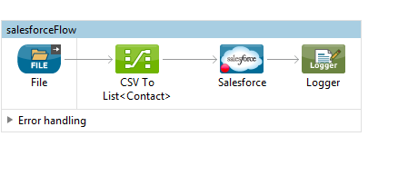
Salesforce Configuration:

- Drag and drop a file connector in source, provide the location of the CSV file in path and give the name of the file in the “File Name Regex Filter” .

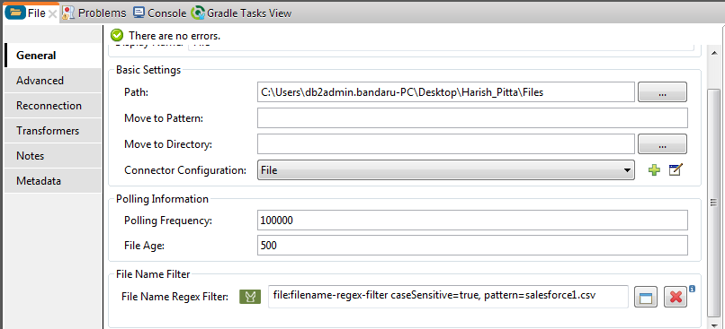

- Drag and Drop the SalesForce connector from the palette
- Click on connector configuration and then click on New connector configuration.
- Select Basic auth mode
- Provide user name, password and Security token(This token has send to your email after creating salesforce account OR click on user->Settings->MyPersonal Information->Reset My security token it will send security token to your email) and click on validate configuration.
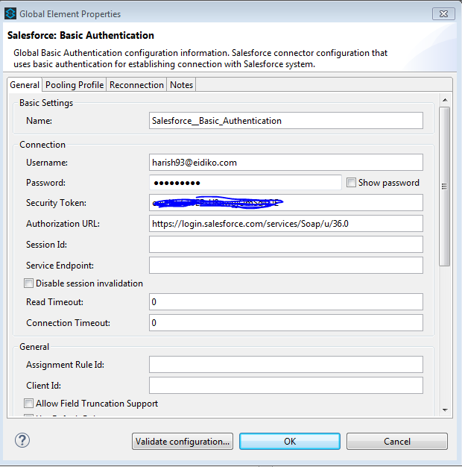

- Dran and drop data mapper between file and salesforce contacts and map the elements between csv file and salesforce contacts
